EXPERIMENT – 1. N .gowtham naik 19211137

DATE-10/01/2023.

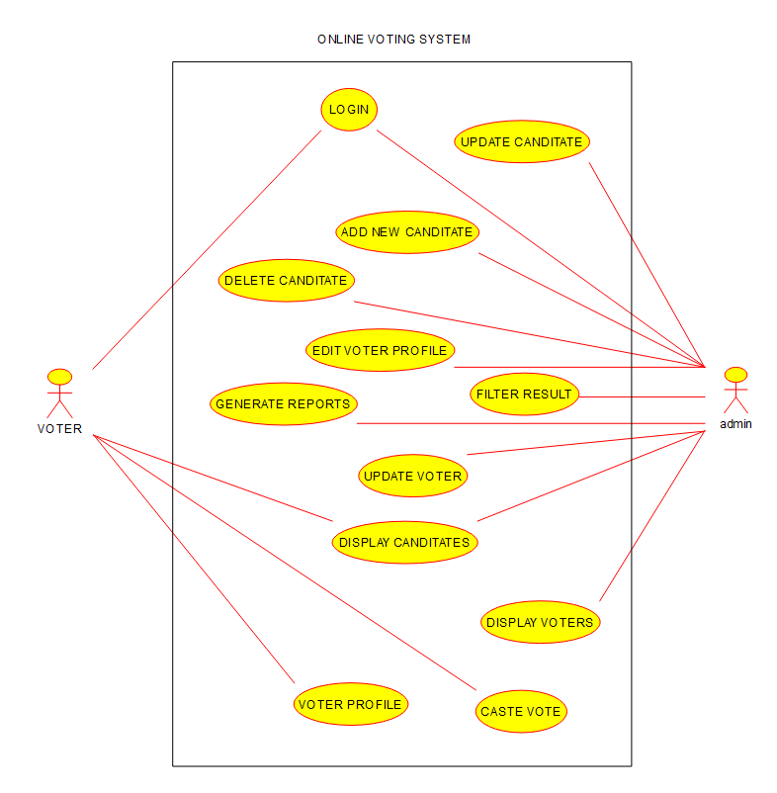

EXPERIMENT – 2.

10/01/23

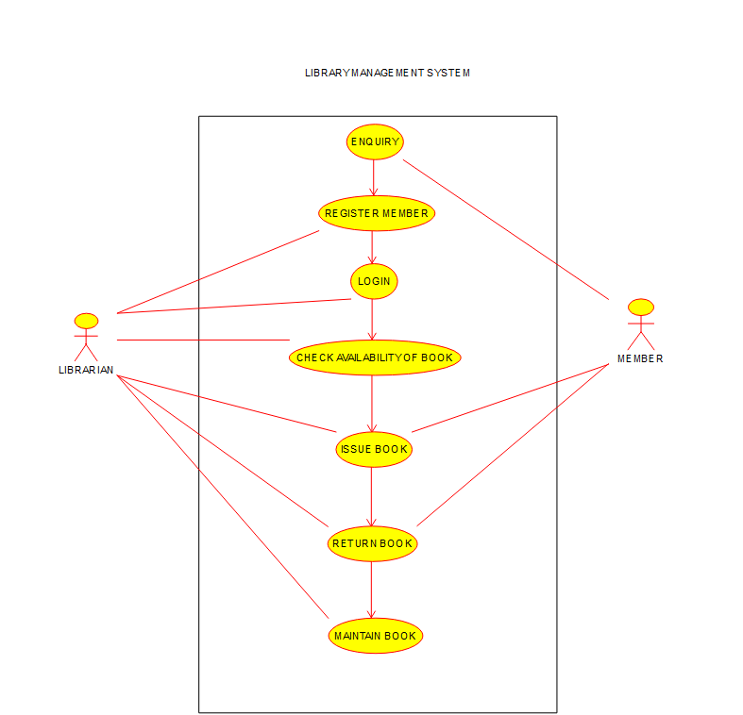

EXPERIMENT – 3.

10/01/23

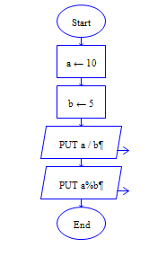

Output

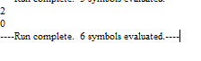

EXPERIMENT-4

10/01/2023

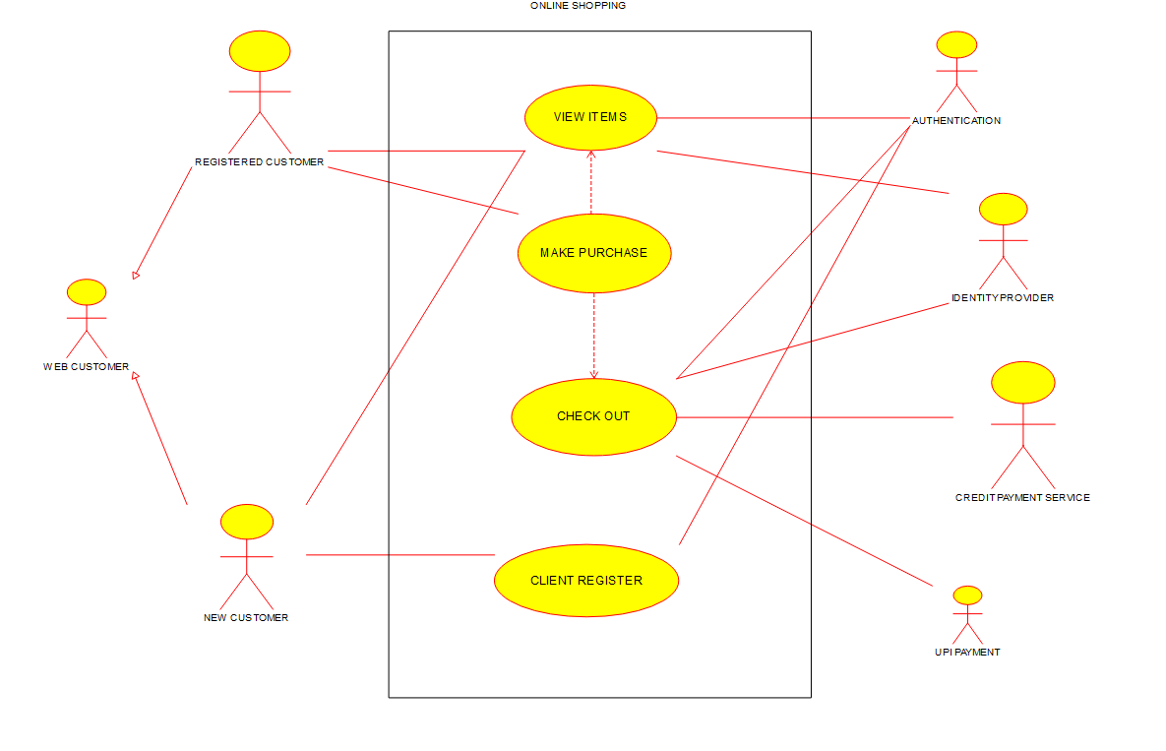

EXPERIMENT-5

10/01/2023

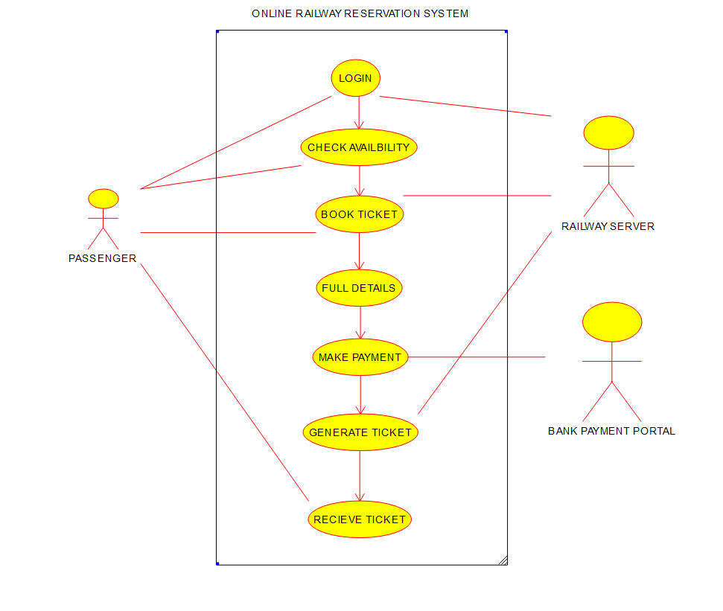

EXPERIMENT – 6.

10/01/2023

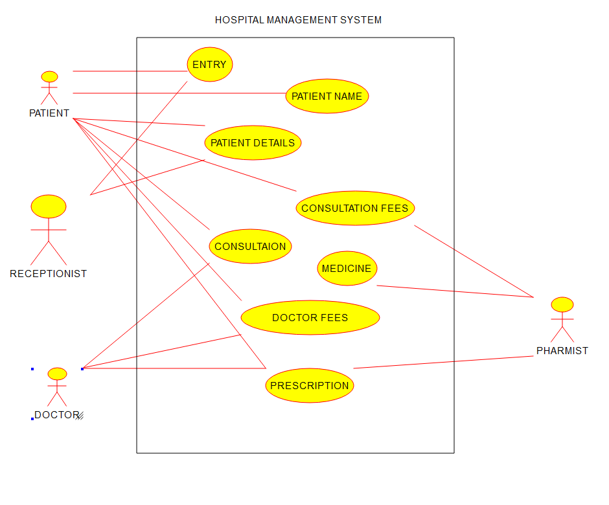

EXPERIMENT – 7

10/01/2023

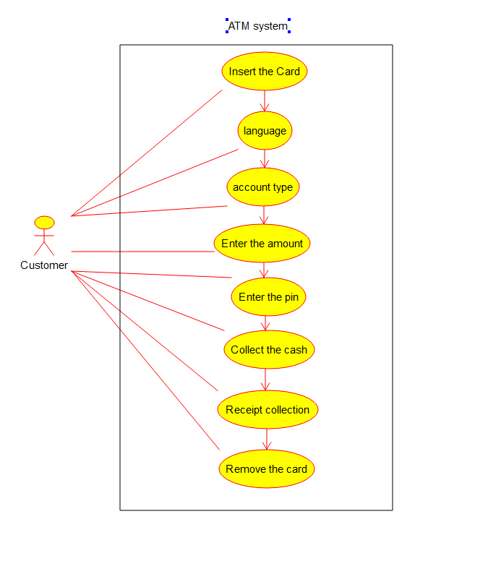

EXPERIMENT – 8.

10/01/2023

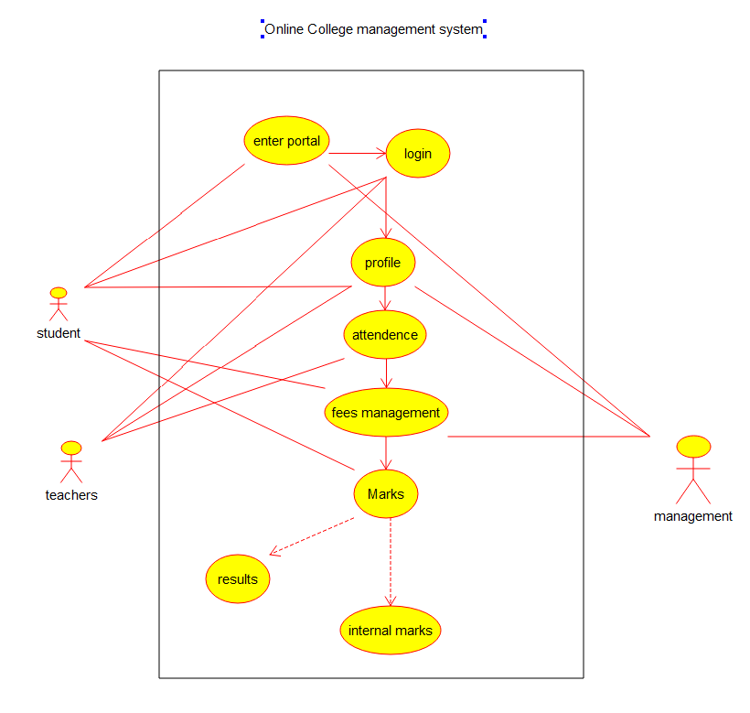

EXPERIMENT – 9.

10/01/2023

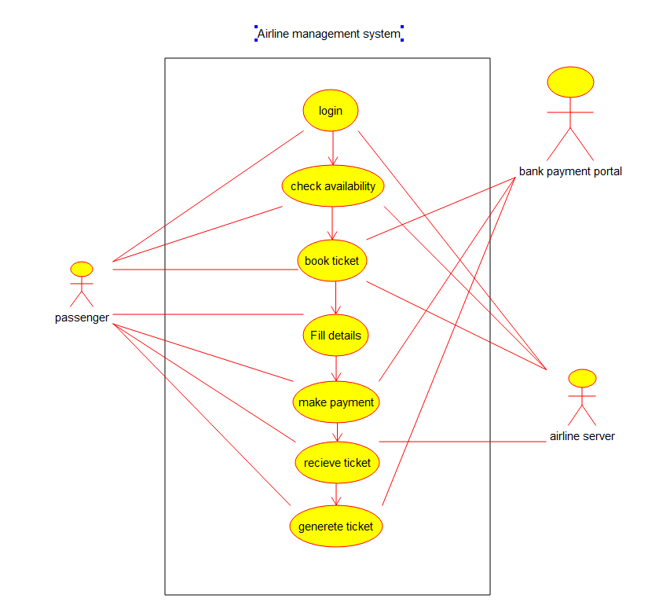

EXPERIMENT – 10.

10/01/2023

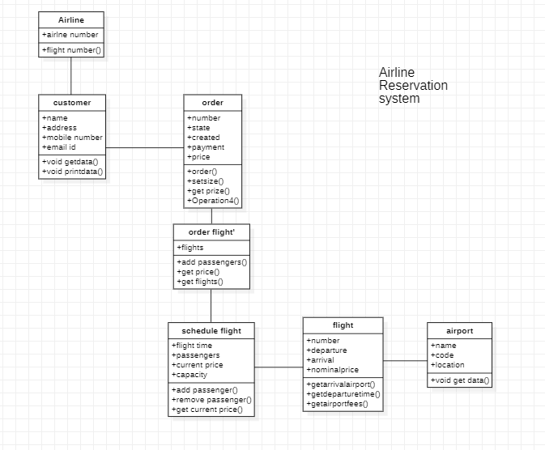

EXPERIMENT – 11.

10/01/2023

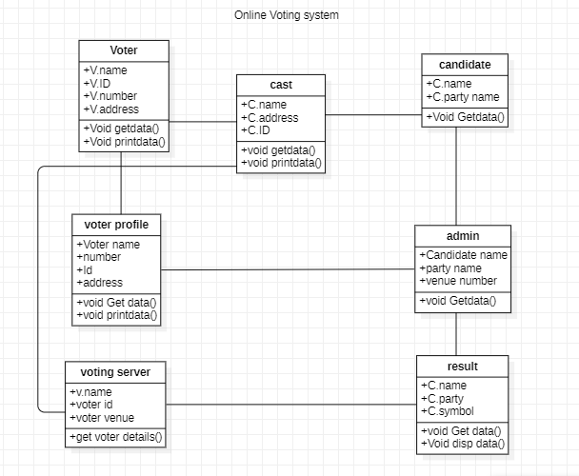

EXPERIMENT – 12.

10/01/2023

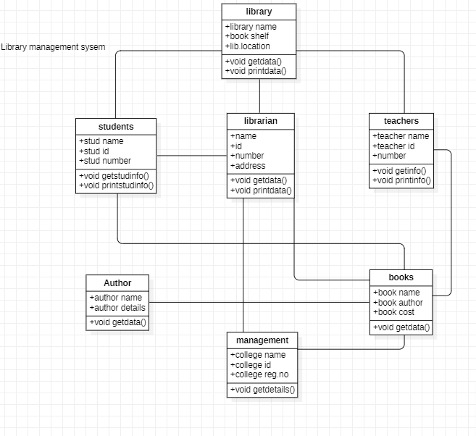

EXPERIMENT – 13.

10/01/2023

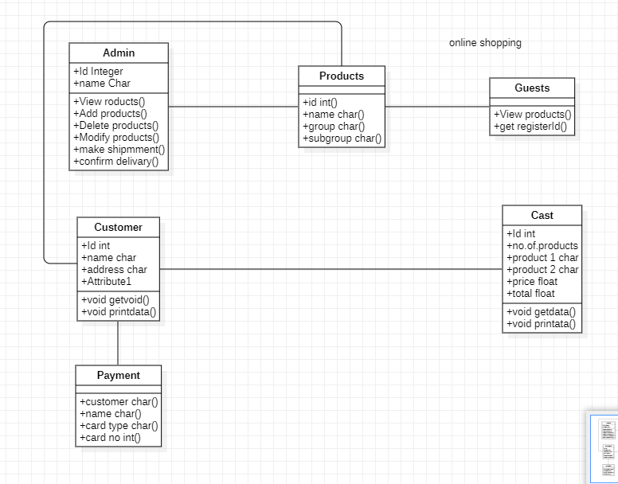

EXPERIMENT – 14.

10/01/2023

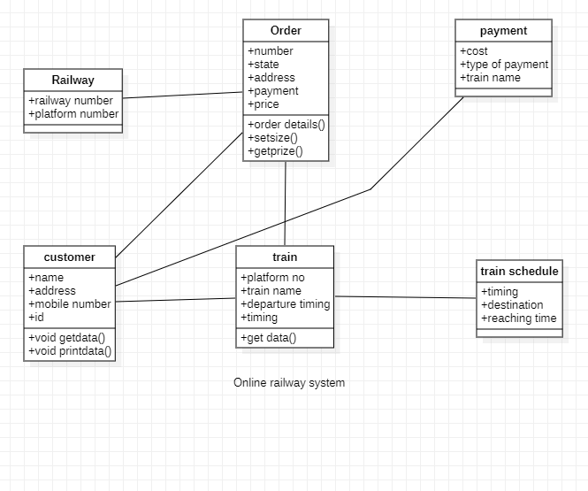

EXPERIMENT – 15.

10/01/2023

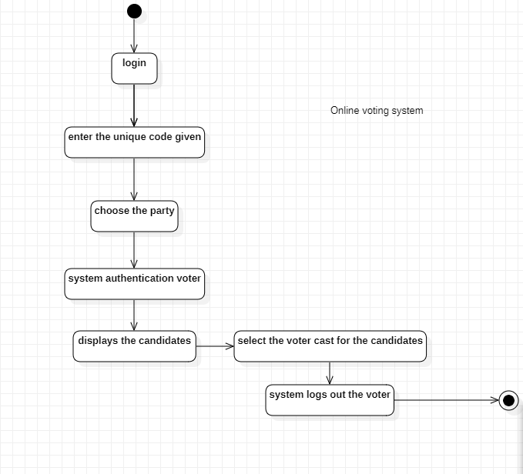

EXPERIMENT – 16.

10/01/2023

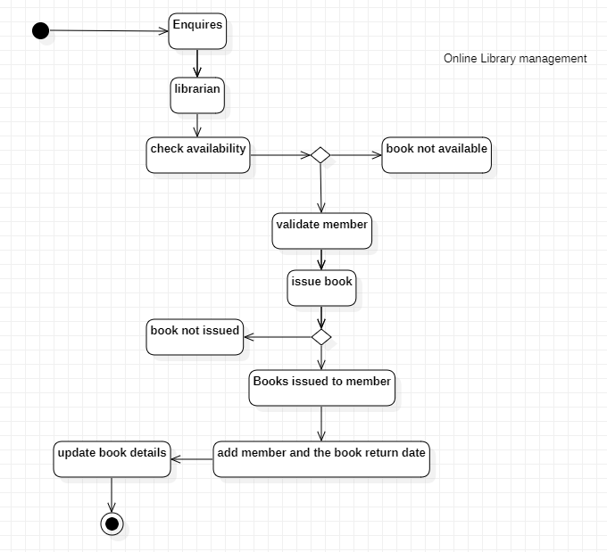

EXPERIMENT – 17.

10/01/2023

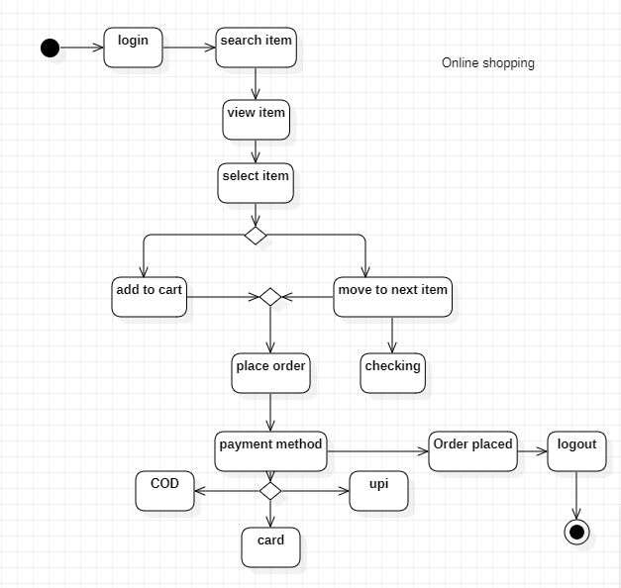

EXPERIMENT – 18.

10/01/2023

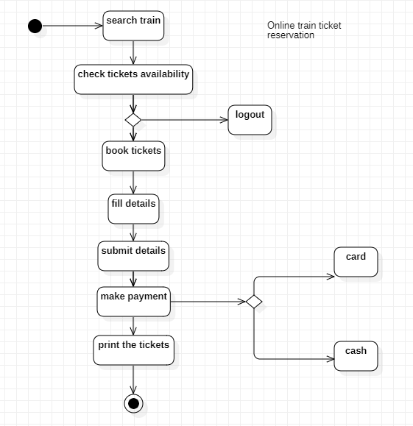

EXPERIMENT – 19.

10/01/2023

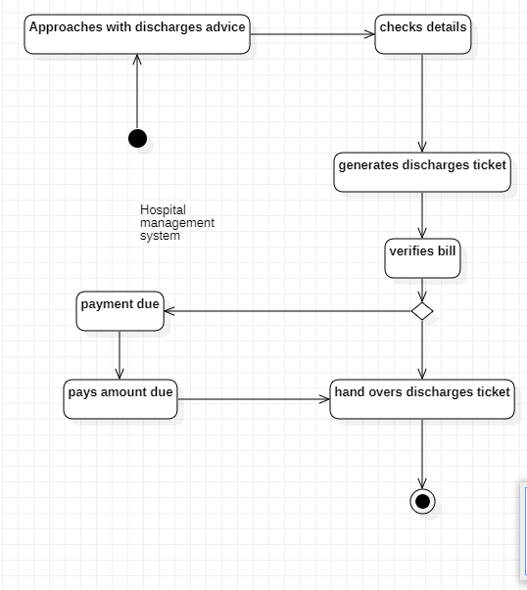

EXPERIMENT – 20.

10/01/2023

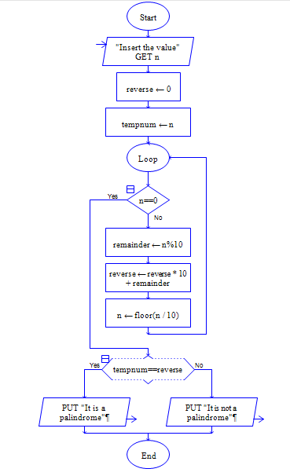

Output:



EXPERIMENT – 21.

10/01/2023

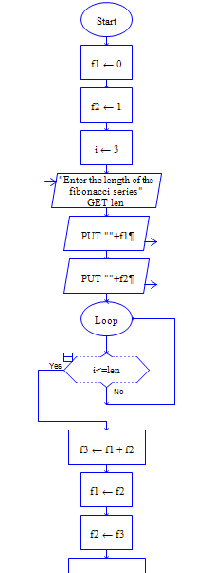Output.



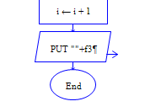

EXPERIMENT – 22.

10/01/2023

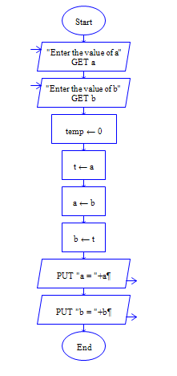

Output:



EXPERIMENT – 23.

10/01/2023

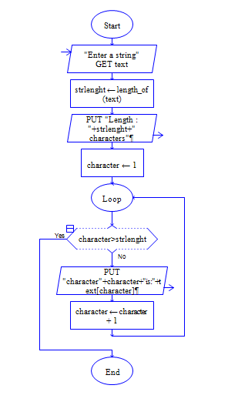

Output:

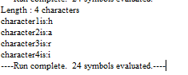

EXPERIMENT – 24.

10/01/2023

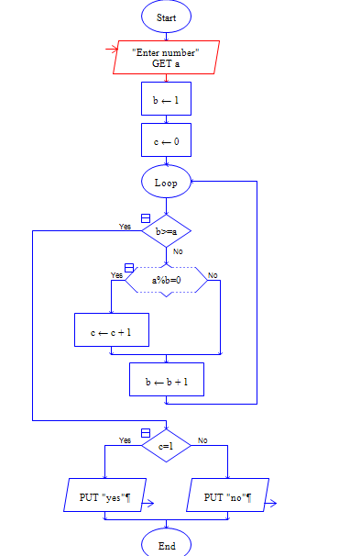

Output:



EXPERIMENT -25.

10/01/2023

